Chapter 17

Recovery System

Failure Classification

Storage Structure

Recovery and Atomicity

Log-Based Recovery

Shadow Paging

Recovery With Concurrent Transactions

Buffer Management

Failure with Loss of Nonvolatile Storage

Advanced Recovery Techniques

ARIES Recovery Algorithm

Remote Backup Systems

Failure Classification

Transaction failure :

Logical errors: transaction cannot complete due to some internal error condition

System errors: the database system must terminate an active transaction due to an error condition (e.g., deadlock)

System crash: a power failure or other hardware or software failure causes the system to crash.

Fail-stop assumption: non-volatile storage contents are assumed to not be corrupted by system crash

Database systems have numerous integrity checks to prevent corruption of disk data

Disk failure: a head crash or similar disk failure destroys all or part of disk storage

Destruction is assumed to be detectable: disk drives use checksums to detect failures

Recovery Algorithms

Recovery algorithms are techniques to ensure database consistency and transaction atomicity and durability despite failures

Focus of this chapter

Recovery algorithms have two parts

Actions taken during normal transaction processing to ensure enough information exists to recover from failures

Actions taken after a failure to recover the database contents to a state that ensures atomicity, consistency and durability

Storage Structure

Volatile storage:

does not survive system crashes

examples: main memory, cache memory

Nonvolatile storage:

survives system crashes

examples: disk, tape, flash memory,
non-volatile (battery backed up) RAM

Stable storage:

a mythical form of storage that survives all failures

approximated by maintaining multiple copies on distinct nonvolatile media

Stable-Storage Implementation

Maintain multiple copies of each block on separate disks

copies can be at remote sites to protect against disasters such as fire or flooding.

Failure during data transfer can still result in inconsistent copies: Block transfer can result in

Successful completion

Partial failure: destination block has incorrect information

Total failure: destination block was never updated

Protecting storage media from failure during data transfer (one solution):

Execute output operation as follows (assuming two copies of each block):

Write the information onto the first physical block.

When the first write successfully completes, write the same information onto the second physical block.

The output is completed only after the second write successfully completes.

Protecting storage media from failure during data transfer (cont.):

Copies of a block may differ due to failure during output operation. To recover from failure:

First find inconsistent blocks:

Expensive solution: Compare the two copies of every disk block.

Better solution:

Record in-progress disk writes on non-volatile storage (Non-volatile RAM or special area of disk).

Use this information during recovery to find blocks that may be inconsistent, and only compare copies of these.

Used in hardware RAID systems

If either copy of an inconsistent block is detected to have an error (bad checksum), overwrite it by the other copy. If both have no error, but are different, overwrite the second block by the first block.

Data Access

Physical blocks are those blocks residing on the disk.

Buffer blocks are the blocks residing temporarily in main memory.

Block movements between disk and main memory are initiated through the following two operations:

input(B) transfers the physical block B to main memory.

output(B) transfers the buffer block B to the disk, and replaces the appropriate physical block there.

Each transaction T_{i} has its private work-area in which local copies of all data items accessed and updated by it are kept.

T_{i}'s local copy of a data item X is called x_{i}.

We assume, for simplicity, that each data item fits in, and is stored inside, a single block.

Transaction transfers data items between system buffer blocks and its private work-area using the following operations :

read(X) assigns the value of data item X to the local variable x_{i}.

write(X) assigns the value of local variable x_{i} to data item {X} in the buffer block.

both these commands may necessitate the issue of an input(B_{X}) instruction before the assignment, if the block B_{X} in which X resides is not already in memory.

Transactions

Perform read(X) while accessing X for the first time;

All subsequent accesses are to the local copy.

After last access, transaction executes write(X).

output(B_{X}) need not immediately follow write(X). System can perform the output operation when it deems fit.

Example of Data Access

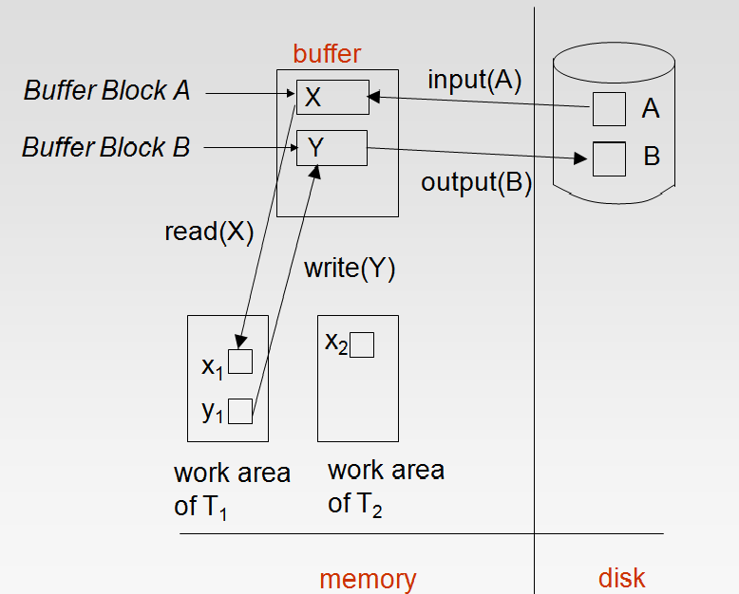

Recovery and Atomicity

Modifying the database without ensuring that the transaction will commit may leave the database in an inconsistent state.

Consider transaction T_{i} that transfers $50 from account A to account B; goal is either to perform all database modifications made by T_{i} or none at all.

Several output operations may be required for T_{i} (to output A and B). A failure may occur after one of these modifications have been made but before all of them are made.

To ensure atomicity despite failures, we first output information describing the modifications to stable storage without modifying the database itself.

We study two approaches:

log-based recovery, and

shadow-paging

We assume (initially) that transactions run serially, that is, one after the other.

Log-Based Recovery

A log is kept on stable storage.

The log is a sequence of log records, and maintains a record of update activities on the database.

When transaction T_{i} starts, it registers itself by writing a
<T_{i} start>log record

Before T_{i} executes write(X), a log record <T_{i}, X, V₁, V₂> is written, where V₁ is the value of X before the write, and V₂ is the value to be written to X.

Log record notes that T_{i} has performed a write on data item X_{j} X_{j} had value V₁ before the write, and will have value V₂ after the write.

When T_{i} finishes it last statement, the log record <T_{i} commit> is written.

We assume for now that log records are written directly to stable storage (that is, they are not buffered)

Two approaches using logs

Deferred database modification

Immediate database modification

Deferred Database Modification

The deferred database modification scheme records all modifications to the log, but defers all the writes to after partial commit.

Assume that transactions execute serially

Transaction starts by writing <T_{i} start> record to log.

A write(X) operation results in a log record <T_{i}, X, V> being written, where V is the new value for X

Note: old value is not needed for this scheme

The write is not performed on X at this time, but is deferred.

When T_{i} partially commits, <T_{i} commit> is written to the log

Finally, the log records are read and used to actually execute the previously deferred writes.

During recovery after a crash, a transaction needs to be redone if and only if both <T_{i} start> and<T_{i} commit> are there in the log.

Redoing a transaction T_{i} ( redoT_{i}) sets the value of all data items updated by the transaction to the new values.

Crashes can occur while

the transaction is executing the original updates, or

while recovery action is being taken

example transactions T₀ and T₁ (T₀ executes before T₁):

T₀: read (A) T₁ : read (C)

A: - A - 50 C:- C- 100

Write (A) write (C)

read (B)

B:- B + 50

write (B)

Below we show the log as it appears at three instances of time.

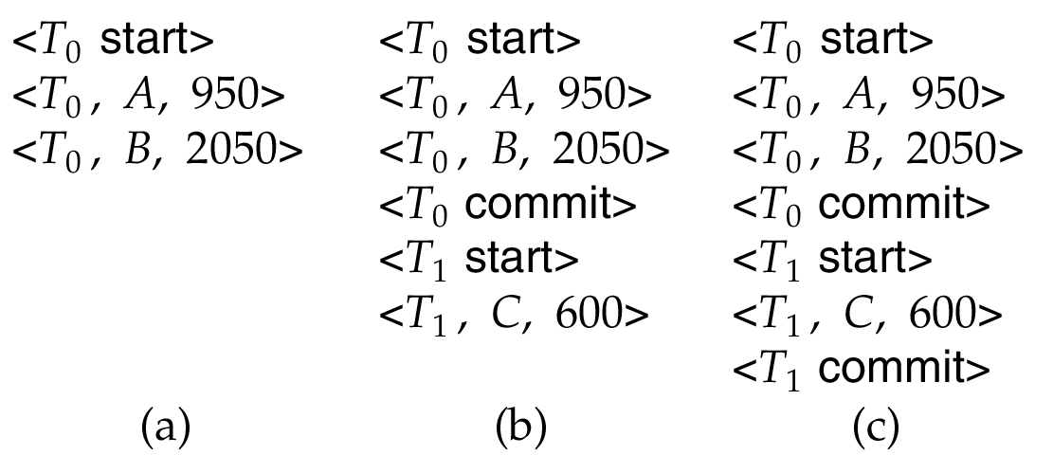

If log on stable storage at time of crash is as in case:

(a) No redo actions need to be taken

(b) redo(T₀) must be performed since <T₀ commit> is present

(c) redo(T₀) must be performed followed by redo(T₁) since

<T₀ commit> and <T_{i} commit> are present

Immediate Database Modification

The immediate database modification scheme allows database updates of an uncommitted transaction to be made as the writes are issued

since undoing may be needed, update logs must have both old value and new value

Update log record must be written before database item is written

We assume that the log record is output directly to stable storage

Can be extended to postpone log record output, so long as prior to execution of an output(B) operation for a data block B, all log records corresponding to items B must be flushed to stable storage

Output of updated blocks can take place at any time before or after transaction commit

Order in which blocks are output can be different from the order in which they are written.

Immediate Database Modification Example

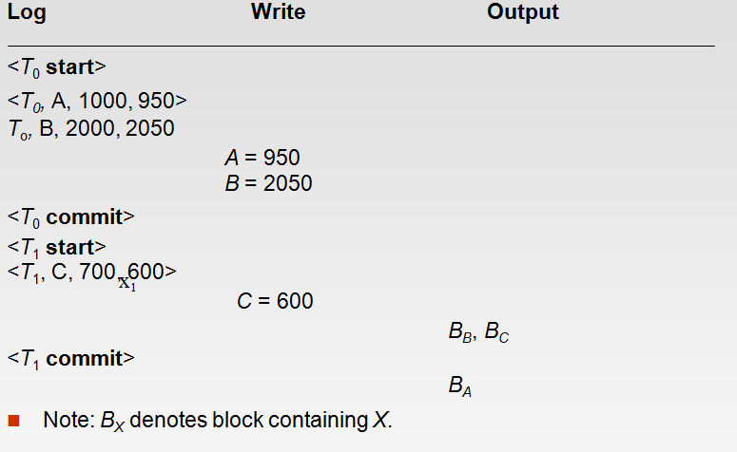

Recovery procedure has two operations instead of one:

undo(T_{i}) restores the value of all data items updated by T_{i} to their old values, going backwards from the last log record for T_{i}

redo(T_{i}) sets the value of all data items updated by T_{i} to the new values, going forward from the first log record for T_{i}

Both operations must be idempotent

That is, even if the operation is executed multiple times the effect is the same as if it is executed once

Needed since operations may get re-executed during recovery

When recovering after failure:

Transaction T_{i} needs to be undone if the log contains the record
<T_{i} start>, but does not contain the record <T_{i} commit>.

Transaction T_{i} needs to be redone if the log contains both the record <T_{i} start> and the record <T_{i} commit>.

Undo operations are performed first, then redo operations.

Immediate DB Modification Recovery Example

Below we show the log as it appears at three instances of time.

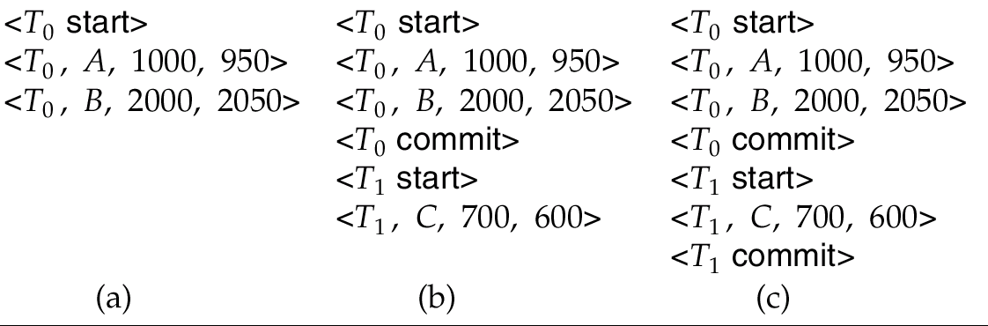

Recovery actions in each case above are:

(a) undo (T₀): B is restored to 2000 and A to 1000.

(b) undo (T₁) and redo (T₀): C is restored to 700, and then A and B are

set to 950 and 2050 respectively.

(c) redo (T₀) and redo (T₁): A and B are set to 950 and 2050

respectively. Then C is set to 600

Checkpoints

Problems in recovery procedure as discussed earlier :

searching the entire log is time-consuming

we might unnecessarily redo transactions which have already

output their updates to the database.

Streamline recovery procedure by periodically performing checkpointing

Output all log records currently residing in main memory onto stable storage.

Output all modified buffer blocks to the disk.

Write a log record < checkpoint> onto stable storage.

During recovery we need to consider only the most recent transaction T_{i} that started before the checkpoint, and transactions that started after T_{i}.

Scan backwards from end of log to find the most recent <checkpoint> record

Continue scanning backwards till a record <T_{i} start> is found.

Need only consider the part of log following above start record. Earlier part of log can be ignored during recovery, and can be erased whenever desired.

For all transactions (starting from T_{i} or later) with no <T_{i} commit>, execute undo(T_{i}). (Done only in case of immediate modification.)

Scanning forward in the log, for all transactions starting from T_{i} or later with a <T_{i} commit>, execute redo(T_{i}).

Example of Checkpoints

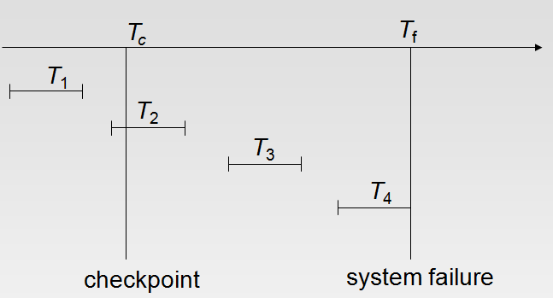

T₁ can be ignored (updates already output to disk due to checkpoint)

T₂ and T₃ redone.

T₄ undone

Recovery With Concurrent Transactions

We modify the log-based recovery schemes to allow multiple transactions to execute concurrently.

All transactions share a single disk buffer and a single log

A buffer block can have data items updated by one or more transactions

We assume concurrency control using strict two-phase locking;

i.e. the updates of uncommitted transactions should not be visible to other transactions

Otherwise how to perform undo if T1 updates A, then T2 updates A and commits, and finally T1 has to abort?

Logging is done as described earlier.

Log records of different transactions may be interspersed in the log.

The checkpointing technique and actions taken on recovery have to be changed

since several transactions may be active when a checkpoint is performed.

Checkpoints are performed as before, except that the checkpoint log record is now of the form
< checkpoint L>
where L is the list of transactions active at the time of the checkpoint

We assume no updates are in progress while the checkpoint is carried out (will relax this later)

When the system recovers from a crash, it first does the following:

Initialize undo-list and redo-list to empty

Scan the log backwards from the end, stopping when the first <checkpoint L> record is found.
For each record found during the backward scan:

if the record is <T_{i} commit>, add T_{i} to redo-list

if the record is <T_{i} start>, then if T_{i} is not in redo-list, add T_{i} to undo-list

For every T_{i} in L, if T_{i} is not in redo-list, add T_{i} to undo-list

At this point undo-list consists of incomplete transactions which must be undone, and redo-list consists of finished transactions that must be redone.

Recovery now continues as follows:

Scan log backwards from most recent record, stopping when
<T_{i} start> records have been encountered for every T_{i} in undo-list.

During the scan, perform undo for each log record that belongs to a transaction in undo-list.

Locate the most recent <checkpoint L> record.

Scan log forwards from the <checkpoint L> record till the end of the log.

During the scan, perform redo for each log record that belongs to a transaction on redo-list

Example of Recovery

Go over the steps of the recovery algorithm on the following log:

<T₀ start>

<T₀, A, 0, 10>

<T₀ commit>

<T₁ start> /* Scan at step 1 comes up to here */

<T₁, B, 0, 10>

<T₂ start>

<T₂, C, 0, 10>

<T₂, C, 10, 20>

<checkpoint {T₁, T₂}>

<T₃ start>

<T₃, A, 10, 20>

<T₃, D, 0, 10>

<T₃ commit>

Log Record Buffering

Log record buffering: log records are buffered in main memory, instead of of being output directly to stable storage.

Log records are output to stable storage when a block of log records in the buffer is full, or a log force operation is executed.

Log force is performed to commit a transaction by forcing all its log records (including the commit record) to stable storage.

Several log records can thus be output using a single output operation, reducing the I/O cost.

The rules below must be followed if log records are buffered:

Log records are output to stable storage in the order in which they are created.

Transaction T_{i} enters the commit state only when the log record
<T_{i} commit> has been output to stable storage.

Before a block of data in main memory is output to the database, all log records pertaining to data in that block must have been output to stable storage.

This rule is called the write-ahead logging or WAL rule

Strictly speaking WAL only requires undo information to be output

Database Buffering

Database maintains an in-memory buffer of data blocks

When a new block is needed, if buffer is full an existing block needs to be removed from buffer

If the block chosen for removal has been updated, it must be output to disk

If a block with uncommitted updates is output to disk, log records with undo information for the updates are output to the log on stable storage first

(Write ahead logging)

No updates should be in progress on a block when it is output to disk. Can be ensured as follows.

Before writing a data item, transaction acquires exclusive lock on block containing the data item

Lock can be released once the write is completed.

Such locks held for short duration are called latches.

Before a block is output to disk, the system acquires an exclusive latch on the block

Ensures no update can be in progress on the block

Database buffer can be implemented either

in an area of real main-memory reserved for the database, or

in virtual memory

Implementing buffer in reserved main-memory has drawbacks:

Memory is partitioned before-hand between database buffer and applications, limiting flexibility.

Needs may change, and although operating system knows best how memory should be divided up at any time, it cannot change the partitioning of memory.

Database buffers are generally implemented in virtual memory in spite of some drawbacks:

When operating system needs to evict a page that has been modified, the page is written to swap space on disk.

When database decides to write buffer page to disk, buffer page may be in swap space, and may have to be read from swap space on disk and output to the database on disk, resulting in extra I/O!

Known as dual paging problem.

Ideally when OS needs to evict a page from the buffer, it should pass control to database, which in turn should

Output the page to database instead of to swap space (making sure to output log records first), if it is modified

Release the page from the buffer, for the OS to use

Dual paging can thus be avoided, but common operating systems do not support such functionality.

Failure with Loss of Nonvolatile Storage

So far we assumed no loss of non-volatile storage

Technique similar to checkpointing used to deal with loss of non-volatile storage

Periodically dump the entire content of the database to stable storage

No transaction may be active during the dump procedure; a procedure similar to checkpointing must take place

Output all log records currently residing in main memory onto stable storage.

Output all buffer blocks onto the disk.

Copy the contents of the database to stable storage.

Output a record <dump> to log on stable storage.

Recovering from Failure of Non-Volatile Storage

To recover from disk failure

restore database from most recent dump.

Consult the log and redo all transactions that committed after the dump

Can be extended to allow transactions to be active during dump;
known as fuzzy dump or online dump

Will study fuzzy checkpointing later

Advanced Recovery Algorithm

Advanced Recovery: Key Features

Support for high-concurrency locking techniques, such as those used for B⁺-tree concurrency control, which release locks early

Supports “logical undo”

Recovery based on “repeating history”, whereby recovery executes exactly the same actions as normal processing

including redo of log records of incomplete transactions, followed by subsequent undo

Key benefits

supports logical undo

easier to understand/show correctness

Advanced Recovery: Logical Undo Logging

Operations like B⁺-tree insertions and deletions release locks early.

They cannot be undone by restoring old values (physical undo), since once a lock is released, other transactions may have updated the B⁺-tree.

Instead, insertions (resp. deletions) are undone by executing a deletion (resp. insertion) operation (known as logical undo).

For such operations, undo log records should contain the undo operation to be executed

Such logging is called logical undo logging, in contrast to physical undo logging

Operations are called logical operations

Other examples:

delete of tuple, to undo insert of tuple

allows early lock release on space allocation information

subtract amount deposited, to undo deposit

allows early lock release on bank balance

Advanced Recovery: Physical Redo

Redo information is logged physically (that is, new value for each write) even for operations with logical undo

Logical redo is very complicated since database state on disk may not be “operation consistent” when recovery starts

Physical redo logging does not conflict with early lock release

Advanced Recovery: Operation Logging

Operation logging is done as follows:

When operation starts, log <T_{i}, O_{j}, operation-begin>. Here O_{j} is a unique identifier of the operation instance.

While operation is executing, normal log records with physical redo and physical undo information are logged.

When operation completes, <T_{i}, O_{j}, operation-end, U> is logged, where U contains information needed to perform a logical undo information.

Example: insert of (key, record-id) pair (K5, RID7) into index I9

If crash/rollback occurs before operation completes:

the operation-end log record is not found, and

the physical undo information is used to undo operation.

If crash/rollback occurs after the operation completes:

the operation-end log record is found, and in this case

logical undo is performed using U; the physical undo information for the operation is ignored.

Redo of operation (after crash) still uses physical redo information.

Advanced Recovery: Txn Rollback

Rollback of transaction T_{i} is done as follows:

Scan the log backwards

If a log record <T_{i}, X, V₁, V₂> is found, perform the undo and log a special redo-only log record <T_{i}, X, V₁>.

If a <T_{i}, O_{j}, operation-end, U> record is found

Rollback the operation logically using the undo information U.

Updates performed during roll back are logged just like during normal operation execution.

At the end of the operation rollback, instead of logging an operation-end record, generate a record

<T_{i}, O_{j}, operation-abort>.

Skip all preceding log records for T_{i} until the record
<T_{i}, O_{j} operation-begin> is found

Scan the log backwards (cont.):

If a redo-only record is found ignore it

If a <T_{i}, O_{j}, operation-abort> record is found:

skip all preceding log records for T_{i} until the record
<T_{i}, O_{j}, operation-begin> is found.

Stop the scan when the record <T_{i}, start> is found

Add a <T_{i}, abort> record to the log

Some points to note:

Cases 3 and 4 above can occur only if the database crashes while a transaction is being rolled back.

Skipping of log records as in case 4 is important to prevent multiple rollback of the same operation.

Advanced Recovery: Txn Rollback Example

Example with a complete and an incomplete operation
<T1, start>
<T1, O1, operation-begin>
….
<T1, X, 10, K5>
<T1, Y, 45, RID7>
<T1, O1, operation-end, (delete I9, K5, RID7)>
<T1, O2, operation-begin>
<T1, Z, 45, 70>
← T1 Rollback begins here
<T1, Z, 45> ← redo-only log record during physical undo (of incomplete O2)
<T1, Y, .., ..> ← Normal redo records for logical undo of O1
…
<T1, O1, operation-abort> ← What if crash occurred immediately after this?
<T1, abort>

Advanced Recovery: Crash Recovery

The following actions are taken when recovering from system crash

(Redo phase): Scan log forward from last < checkpoint L> record till end of log

Repeat history by physically redoing all updates of all transactions,

Create an undo-list during the scan as follows

undo-list is set to L initially

Whenever <T_{i} start> is found T_{i} is added to undo-list

Whenever <T_{i} commit> or <T_{i} abort> is found, T_{i} is deleted from undo-list

This brings database to state as of crash, with committed as well as uncommitted transactions having been redone.

Now undo-list contains transactions that are incomplete, that is, have neither committed nor been fully rolled back.

Recovery from system crash (cont.)

(Undo phase): Scan log backwards, performing undo on log records of transactions found in undo-list.

Log records of transactions being rolled back are processed as described earlier, as they are found

Single shared scan for all transactions being undone

When <T_{i} start> is found for a transaction T_{i} in undo-list, write a <T_{i} abort> log record.

Stop scan when <T_{i} start> records have been found for all T_{i} in undo-list

This undoes the effects of incomplete transactions (those with neither commit nor abort log records). Recovery is now complete.

Advanced Recovery: Checkpointing

Checkpointing is done as follows:

Output all log records in memory to stable storage

Output to disk all modified buffer blocks

Output to log on stable storage a < checkpoint L> record.

Transactions are not allowed to perform any actions while checkpointing is in progress.

Fuzzy checkpointing allows transactions to progress while the most time consuming parts of checkpointing are in progress

Performed as described on next slide

Advanced Recovery: Fuzzy Checkpointing

Fuzzy checkpointing is done as follows:

Temporarily stop all updates by transactions

Write a <checkpoint L> log record and force log to stable storage

Note list M of modified buffer blocks

Now permit transactions to proceed with their actions

Output to disk all modified buffer blocks in list M

blocks should not be updated while being output

Follow WAL: all log records pertaining to a block must be output before the block is output

Store a pointer to the checkpoint record in a fixed position last_checkpoint on disk

When recovering using a fuzzy checkpoint, start scan from the checkpoint record pointed to by last_checkpoint

Log records before last_checkpoint have their updates reflected in database on disk, and need not be redone.

Incomplete checkpoints, where system had crashed while performing checkpoint, are handled safely

ARIES Recovery Algorithm

ARIES

ARIES is a state of the art recovery method

Incorporates numerous optimizations to reduce overheads during normal processing and to speed up recovery

The “advanced recovery algorithm” we studied earlier is modeled after ARIES, but greatly simplified by removing optimizations

Unlike the advanced recovery algorithm, ARIES

Uses log sequence number (LSN) to identify log records

Stores LSNs in pages to identify what updates have already been applied to a database page

Physiological redo

Dirty page table to avoid unnecessary redos during recovery

Fuzzy checkpointing that only records information about dirty pages, and does not require dirty pages to be written out at checkpoint time

More coming up on each of the above …

ARIES Optimizations

Physiological redo

Affected page is physically identified, action within page can be logical

Used to reduce logging overheads

e.g. when a record is deleted and all other records have to be moved to fill hole

Physiological redo can log just the record deletion

Physical redo would require logging of old and new values for much of the page

Requires page to be output to disk atomically

Easy to achieve with hardware RAID, also supported by some disk systems

Incomplete page output can be detected by checksum techniques,

But extra actions are required for recovery

Treated as a media failure

ARIES Data Structures

ARIES uses several data structures

Log sequence number (LSN) identifies each log record

Must be sequentially increasing

Typically an offset from beginning of log file to allow fast access

Easily extended to handle multiple log files

Page LSN

Log records of several different types

Dirty page table

ARIES Data Structures: Page LSN

Each page contains a PageLSN which is the LSN of the last log record whose effects are reflected on the page

To update a page:

X-latch the page, and write the log record

Update the page

Record the LSN of the log record in PageLSN

Unlock page

To flush page to disk, must first S-latch page

Thus page state on disk is operation consistent

Required to support physiological redo

PageLSN is used during recovery to prevent repeated redo

Thus ensuring idempotence

ARIES Data Structures: Log Record

Each log record contains LSN of previous log record of the same transaction

LSN in log record may be implicit

Special redo-only log record called compensation log record (CLR) used to log actions taken during recovery that never need to be undone

Serves the role of operation-abort log records used in advanced recovery algorithm

Has a field UndoNextLSN to note next (earlier) record to be undone

Records in between would have already been undone

Required to avoid repeated undo of already undone actions

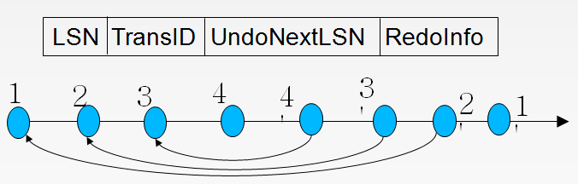

ARIES Data Structures: DirtyPage Table

DirtyPageTable

List of pages in the buffer that have been updated

Contains, for each such page

PageLSN of the page

RecLSN is an LSN such that log records before this LSN have already been applied to the page version on disk

Set to current end of log when a page is inserted into dirty page table (just before being updated)

Recorded in checkpoints, helps to minimize redo work

ARIES Data Structures: Checkpoint Log

Checkpoint log record

Contains:

DirtyPageTable and list of active transactions

For each active transaction, LastLSN, the LSN of the last log record written by the transaction

Fixed position on disk notes LSN of last completed
checkpoint log record

Dirty pages are not written out at checkpoint time

Instead, they are flushed out continuously, in the background

Checkpoint is thus very low overhead

can be done frequently

ARIES Recovery Algorithm

ARIES recovery involves three passes

Analysis pass: Determines

Which transactions to undo

Which pages were dirty (disk version not up to date) at time of crash

RedoLSN: LSN from which redo should start

Redo pass:

Repeats history, redoing all actions from RedoLSN

RecLSN and PageLSNs are used to avoid redoing actions already reflected on page

Undo pass:

Rolls back all incomplete transactions

Transactions whose abort was complete earlier are not undone

Key idea: no need to undo these transactions: earlier undo actions were logged, and are redone as required

Aries Recovery: 3 Passes

Analysis, redo and undo passes

Analysis determines where redo should start

Undo has to go back till start of earliest incomplete transaction

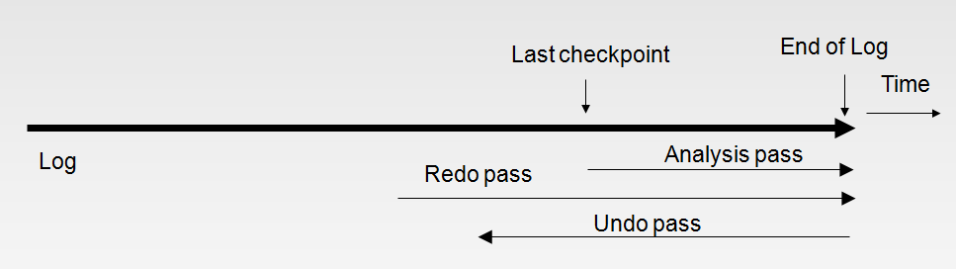

ARIES Recovery: Analysis

Analysis pass

Starts from last complete checkpoint log record

Reads DirtyPageTable from log record

Sets RedoLSN = min of RecLSNs of all pages in DirtyPageTable

In case no pages are dirty, RedoLSN = checkpoint record’s LSN

Sets undo-list = list of transactions in checkpoint log record

Reads LSN of last log record for each transaction in undo-list from checkpoint log record

Scans forward from checkpoint

.. Cont. on next page …

Scans forward from checkpoint

If any log record found for transaction not in undo-list, adds transaction to undo-list

Whenever an update log record is found

If page is not in DirtyPageTable, it is added with RecLSN set to LSN of the update log record

If transaction end log record found, delete transaction from undo-list

Keeps track of last log record for each transaction in undo-list

May be needed for later undo

At end of analysis pass:

RedoLSN determines where to start redo pass

RecLSN for each page in DirtyPageTable used to minimize redo work

All transactions in undo-list need to be rolled back

ARIES Redo Pass

Redo Pass: Repeats history by replaying every action not already reflected in the page on disk, as follows:

Scans forward from RedoLSN. Whenever an update log record is found:

If the page is not in DirtyPageTable or the LSN of the log record is less than the RecLSN of the page in DirtyPageTable, then skip the log record

Otherwise fetch the page from disk. If the PageLSN of the page fetched from disk is less than the LSN of the log record, redo the log record

NOTE: if either test is negative the effects of the log record have already appeared on the page. First test avoids even fetching the page from disk!

ARIES Undo Actions

When an undo is performed for an update log record

Generate a CLR containing the undo action performed (actions performed during undo are logged physicaly or physiologically).

CLR for record n noted as n’ in figure below

Set UndoNextLSN of the CLR to the PrevLSN value of the update log record

Arrows indicate UndoNextLSN value

ARIES supports partial rollback

Used e.g. to handle deadlocks by rolling back just enough to release reqd. locks

Figure indicates forward actions after partial rollbacks

records 3 and 4 initially, later 5 and 6, then full rollback

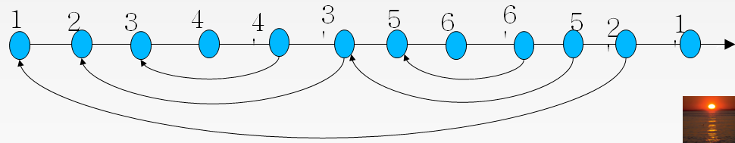

ARIES: Undo Pass

Undo pass:

Performs backward scan on log undoing all transaction in undo-list

Backward scan optimized by skipping unneeded log records as follows:

Next LSN to be undone for each transaction set to LSN of last log record for transaction found by analysis pass.

At each step pick largest of these LSNs to undo, skip back to it and undo it

After undoing a log record

For ordinary log records, set next LSN to be undone for transaction to PrevLSN noted in the log record

For compensation log records (CLRs) set next LSN to be undo to UndoNextLSN noted in the log record

All intervening records are skipped since they would have been undone already

Undos performed as described earlier

Other ARIES Features

Recovery Independence

Pages can be recovered independently of others

E.g. if some disk pages fail they can be recovered from a backup while other pages are being used

Savepoints:

Transactions can record savepoints and roll back to a savepoint

Useful for complex transactions

Also used to rollback just enough to release locks on deadlock

Fine-grained locking:

Index concurrency algorithms that permit tuple level locking on indices can be used

These require logical undo, rather than physical undo, as in advanced recovery algorithm

Recovery optimizations: For example:

Dirty page table can be used to prefetch pages during redo

Out of order redo is possible:

redo can be postponed on a page being fetched from disk, and
performed when page is fetched.

Meanwhile other log records can continue to be processed

Remote Backup Systems

Remote backup systems provide high availability by allowing transaction processing to continue even if the primary site is destroyed.

Detection of failure: Backup site must detect when primary site has failed

to distinguish primary site failure from link failure maintain several communication links between the primary and the remote backup.

Heart-beat messages

Transfer of control:

To take over control backup site first perform recovery using its copy of the database and all the long records it has received from the primary.

Thus, completed transactions are redone and incomplete transactions are rolled back.

When the backup site takes over processing it becomes the new primary

To transfer control back to old primary when it recovers, old primary must receive redo logs from the old backup and apply all updates locally.

Time to recover: To reduce delay in takeover, backup site periodically proceses the redo log records (in effect, performing recovery from previous database state), performs a checkpoint, and can then delete earlier parts of the log.

Hot-Spare configuration permits very fast takeover:

Backup continually processes redo log record as they arrive, applying the updates locally.

When failure of the primary is detected the backup rolls back incomplete transactions, and is ready to process new transactions.

Alternative to remote backup: distributed database with replicated data

Remote backup is faster and cheaper, but less tolerant to failure

more on this in Chapter 19

Ensure durability of updates by delaying transaction commit until update is logged at backup; avoid this delay by permitting lower degrees of durability.

One-safe: commit as soon as transaction’s commit log record is written at primary

Problem: updates may not arrive at backup before it takes over.

Two-very-safe: commit when transaction’s commit log record is written at primary and backup

Reduces availability since transactions cannot commit if either site fails.

Two-safe: proceed as in two-very-safe if both primary and backup are active. If only the primary is active, the transaction commits as soon as is commit log record is written at the primary.

Better availability than two-very-safe; avoids problem of lost transactions in one-safe.

Shadow Paging

Shadow paging is an alternative to log-based recovery; this scheme is useful if transactions execute serially

Idea: maintain two page tables during the lifetime of a transaction –the current page table, and the shadow page table

Store the shadow page table in nonvolatile storage, such that state of the database prior to transaction execution may be recovered.

Shadow page table is never modified during execution

To start with, both the page tables are identical. Only current page table is used for data item accesses during execution of the transaction.

Whenever any page is about to be written for the first time

A copy of this page is made onto an unused page.

The current page table is then made to point to the copy

The update is performed on the copy

Sample Page Table
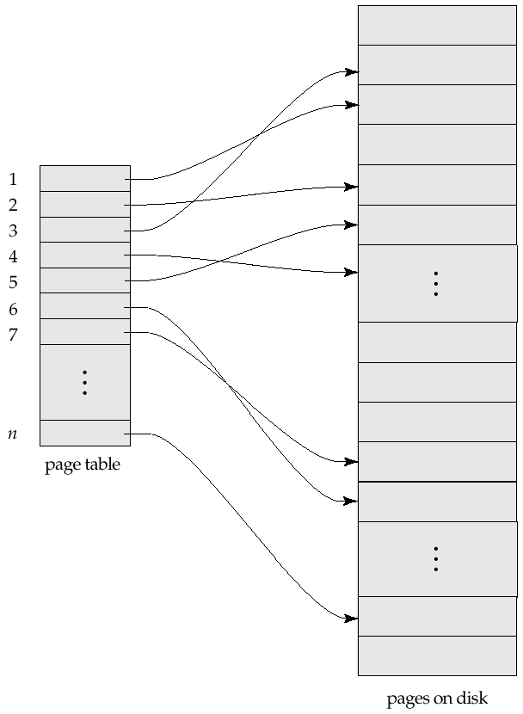

Example of Shadow Paging

To commit a transaction :

1. Flush all modified pages in main memory to disk

2. Output current page table to disk

3. Make the current page table the new shadow page table, as follows:

keep a pointer to the shadow page table at a fixed (known) location on disk.

to make the current page table the new shadow page table, simply update the pointer to point to current page table on disk

Once pointer to shadow page table has been written, transaction is committed.

No recovery is needed after a crash — new transactions can start right away, using the shadow page table.

Pages not pointed to from current/shadow page table should be freed (garbage collected).

Advantages of shadow-paging over log-based schemes

no overhead of writing log records

recovery is trivial

Disadvantages :

Copying the entire page table is very expensive

Can be reduced by using a page table structured like a B⁺-tree

No need to copy entire tree, only need to copy paths in the tree that lead to updated leaf nodes

Commit overhead is high even with above extension

Need to flush every updated page, and page table

Data gets fragmented (related pages get separated on disk)

After every transaction completion, the database pages containing old versions of modified data need to be garbage collected

Hard to extend algorithm to allow transactions to run concurrently

Easier to extend log based schemes

Block Storage Operations
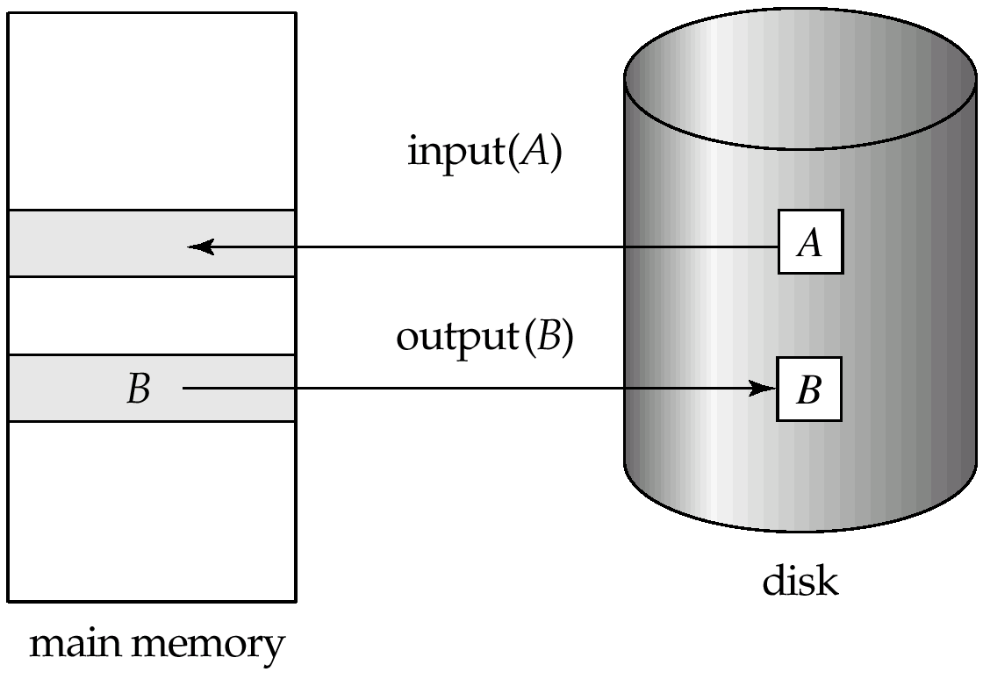

Portion of the Database Log Corresponding to T₀ and T₁
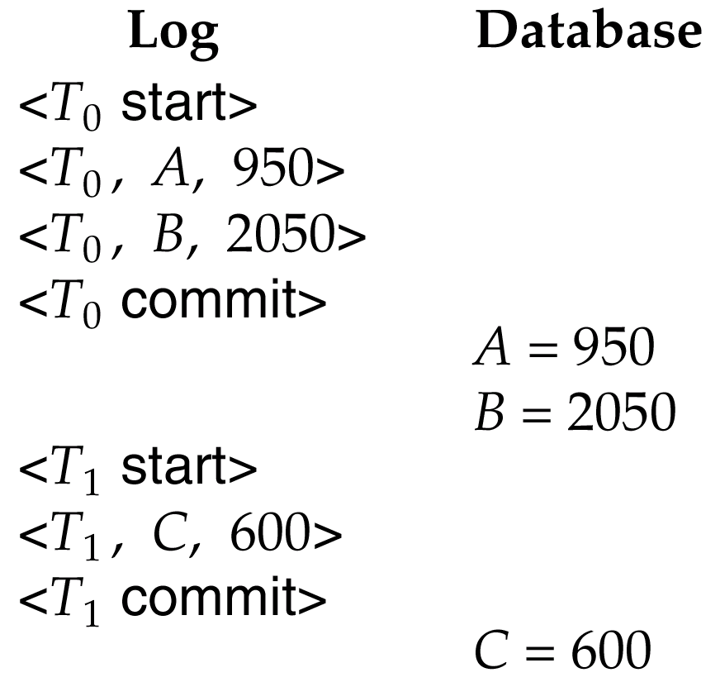

State of the Log and Database Corresponding to T₀ and T₁
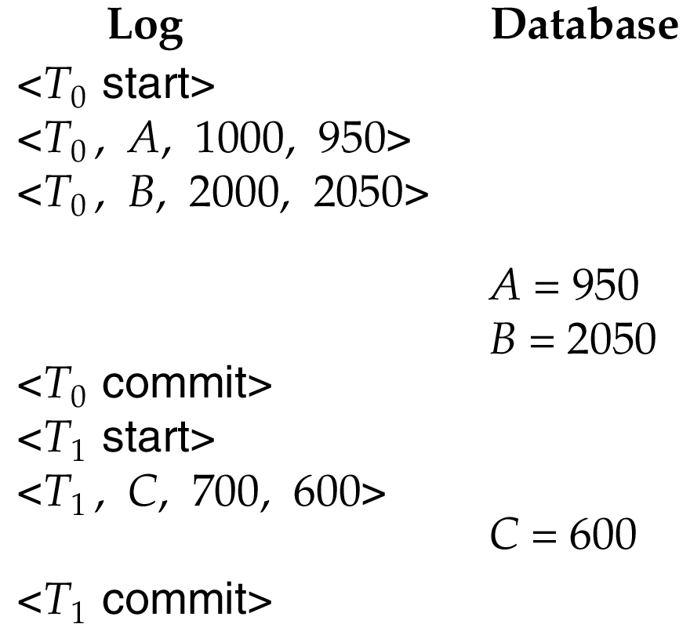

Portion of the System Log Corresponding to T₀ and T₁
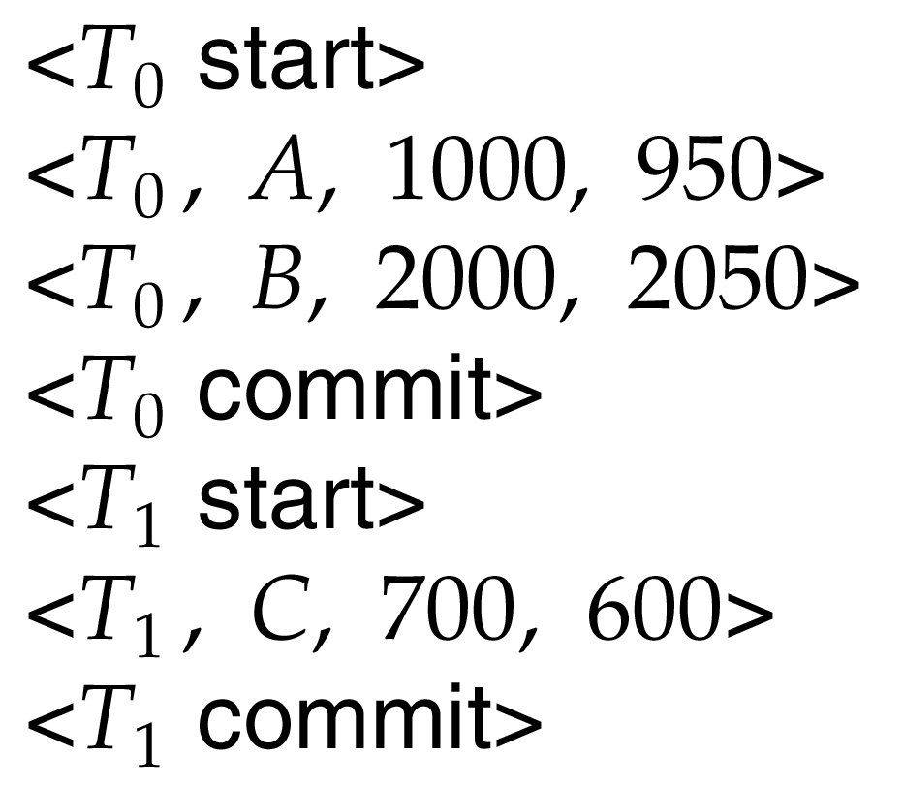

State of System Log and Database Corresponding to T₀ and T₁

